Name: Muhammad Fahad

Id: FA19-BSSE-0014

Course: Operating System Lab

Section: AM

Assignment

Question#1
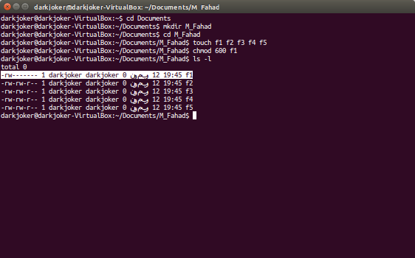
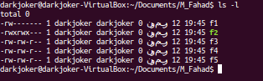

Question#2
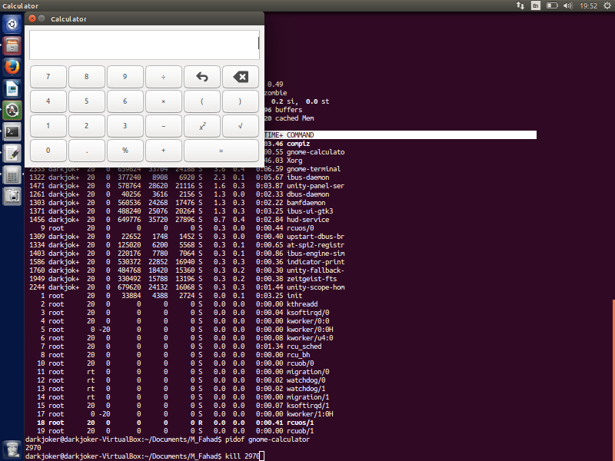
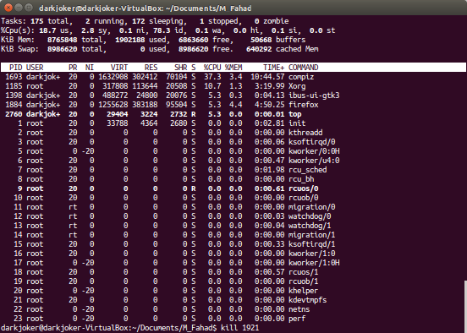

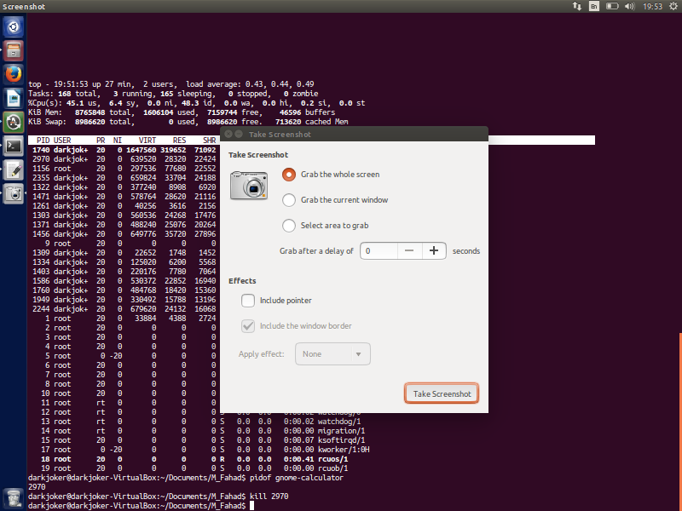
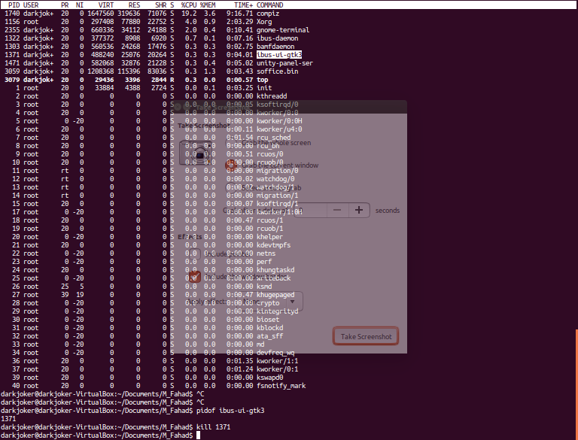

Question # 3

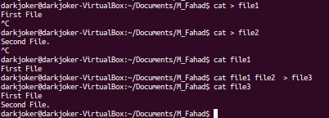
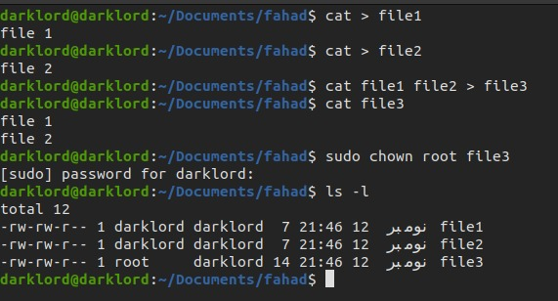

Question # 4
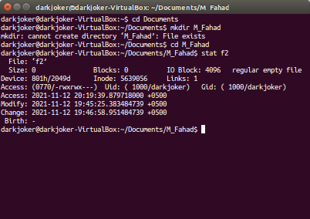
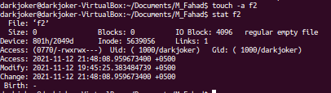

Question # 5
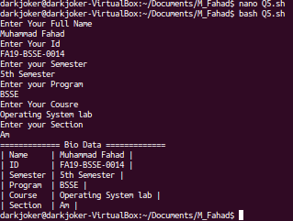

Code:
echo "Enter Your Full Name"
read fName
echo "Enter Your Id"
read id
echo "Enter your Semester"
read semester
echo "Enter your Program"
read program
echo "Enter Your Cousre"
read course
echo "Enter your Section"
read section

echo "============= Bio Data ============="
echo "| Name\t|\t$fName \t|"
echo "| ID\t|\t$id \t|"
echo "| Semester\t|\t$semester \t|"
echo "| Program\t|\t$program \t|"
echo "| Course\t|\t$course \t|"
echo "| Section\t|\t$section \t|"

Question # 6
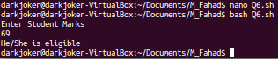

CODE :

#! /bin/sh

echo "Enter Student Marks"
read markss

if [ $marks -ge 50 ]
then
echo "He/She is eligible"
else
echo "Not Eligible!"
fi

Question # 7

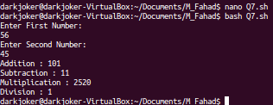

#! /bin/sh

echo "Enter First Number: \b"
read n1
echo "Enter Second Number: \b"
read n2

echo "Addition : `expr $n1 + $n2`"
echo "Subtraction : `expr $n1 - $n2`"
echo "Multiplication : `expr $n1 \* $n2`"
echo "Division : `expr $n1 / $n2`"

